Automatic Hand Sanitizer Dispenser And Face Mask Detection

 Submitted by: B151234(Ch.Saikumar)

B151575(I.Rajeshwari)

B151127(P.Neelima)

DEPARTMENT OF ELECTRONICS and COMMUNICATION ENGINEERING

**RGUKT-BASAR**

# Contents

* Abstract
* Introduction
* Hand Sanitizer
* Components
* Circuitry
* Implementation
* Working model
* Features
* Conclusion
* Future scope
* References

# Abstract

* Corona Virus (COVID 19) is spread almost in every country.
* WHO announced it a pandemic disease and advised people to maintain Healthy Hand Wash and Sanitation habits.
* The main problem is touching hand sanitizers physically can spread the virus to next person.
* We have built an automatic hand sanitizer dispenser to avoid physical touch of sanitizer.
* After the breakout of the worldwide pandemic COVID-19, there arises a severe need of protection mechanisms, face mask being the primary one.
* The basic aim of the project is to detect the presence of a face mask on human faces on live streaming video as well as on images.

# Introduction

* Automatic hand Sanitizer dispenser is used in many places to avoid spreading of germs and to ensure hygiene of people.
* Touch-less Automatic hand Sanitizer uses proximity sensor to detect the presence of hand and activates a pump to pour the liquid on the hand.
* This model is simple, cheap and much more efficient version of touch less sanitizer dispenser.
* Automatic hand Sanitizer was made under limited resources but is functional.
* We are also implemented face mask detection People wear face masks once they step out of their homes and authorities strictly ensure that people are wearing face masks while they are in groups and public places.
* A face mask detector system can be implemented to check this. Face mask detection means to identify whether a person is wearing a mask or not.
* There are many detector systems developed around the world and being implemented. However, all this science needs optimization; a better, more precise detector, because the world cannot afford any more increase in corona cases.

# Hand Sanitisers

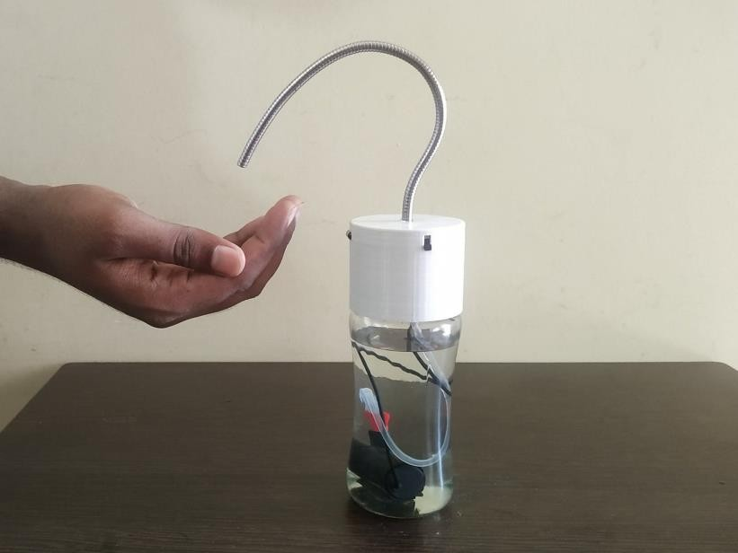

Hand Sanitizers contain alcohol and are specially formulated to destroy

up to 90% of germs and bacteria. It is a viable alternative to hand washing with soap especially where use of water is not appropriate.

# Components

**Proximity Sensor**- sensor detects the presence of nearby objects without any physical contact by emitting electromagnetic field.

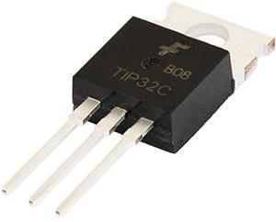**TIP 32C Transistor-** a 3 layer PNP device, Collector current is a function of base current

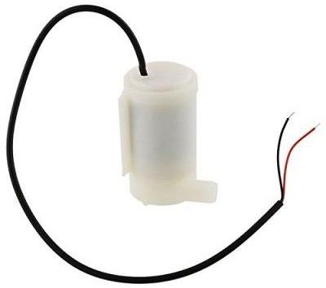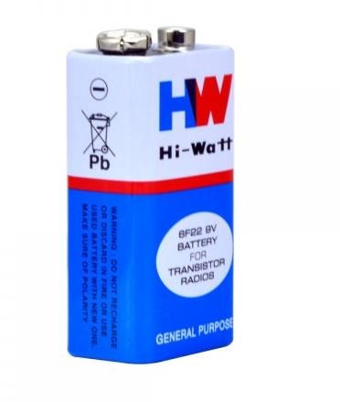

**Dc Water pump** – Submersible

Uses direct current from motor or battery Portable

**9V Battery**,

## Circuitry

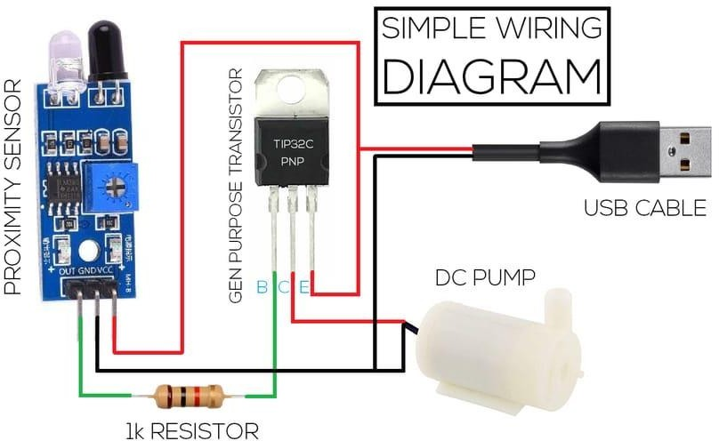

Implementation

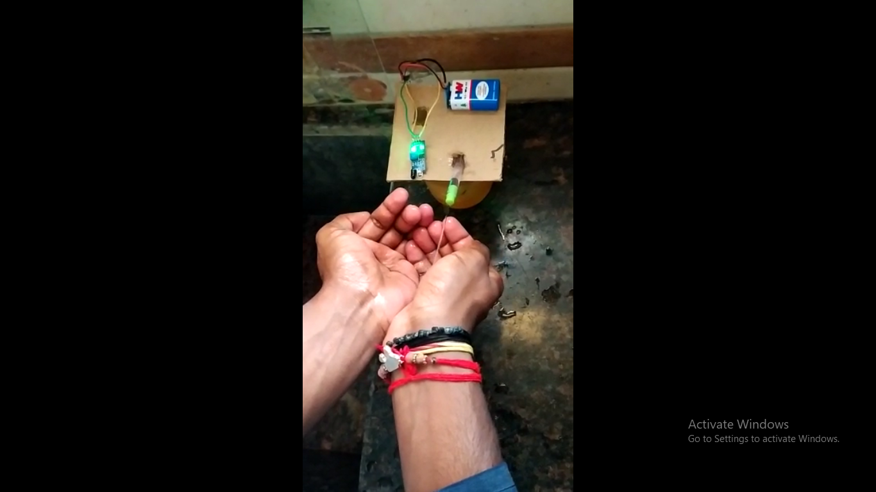

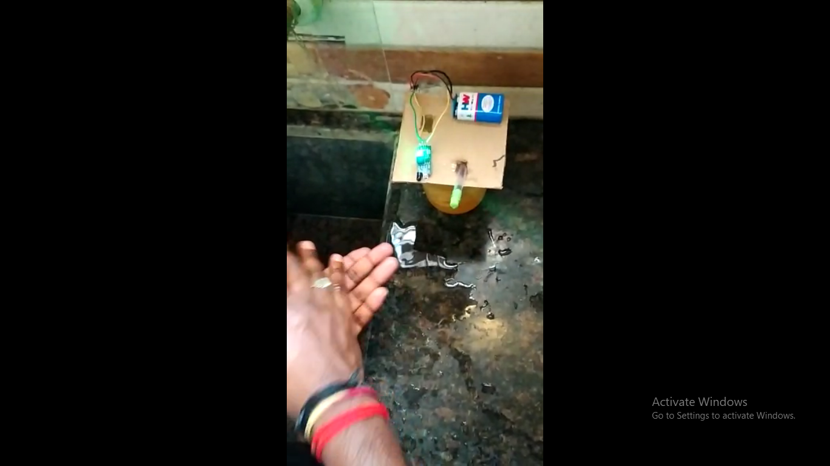

* Its fully automatic operation dispenses sanitizer as soon as you place your hand below it.
* Here we used the proximity sensor which will detect our hand and then is used to start the submersible motor and the sanitizer is dispensed.
* It is convenient and more hygienic. Its 350 ml capacity makes it a perfect sanitizing device for your homes and offices.

# 

# Face mask detection Software requirement Specification

We can use any OS like windows and Ubuntu Tensorflow / Pytroch backend

Anaconda python platform with jupyter notebook

**Technologies used**:

**OpenCv:** **OpenCV** is a huge open-source library for computer vision, machine learning, and image processing. OpenCV supports a wide variety of programming languages like Python, C++, Java, etc. It can process images and videos to identify objects, faces, or even the handwriting of a human.

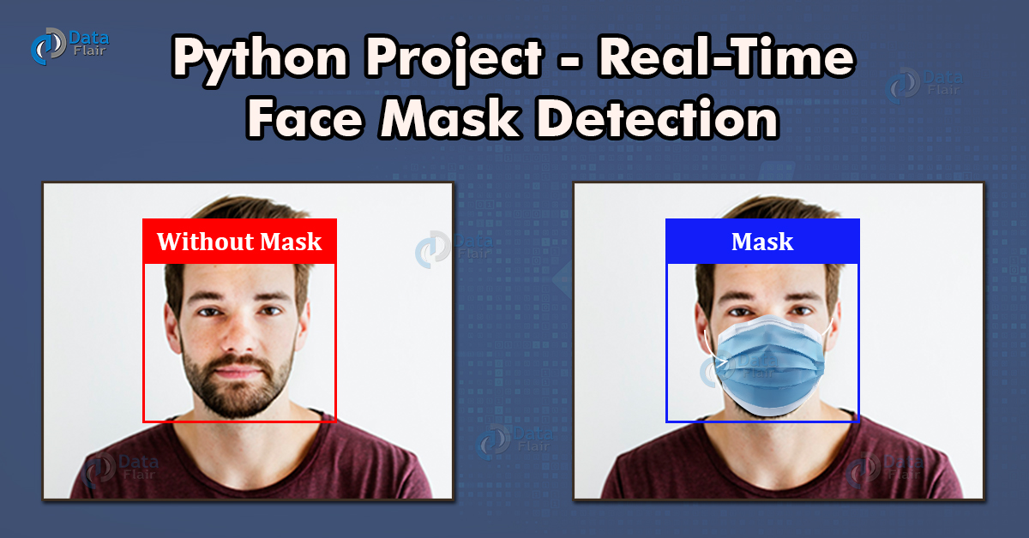

**SUPPORT VECTOR CLASSIFICATION:**

* Support vector machine (svm) has both classification as well as the regression model (svr).The SVC model is same as the simple classification model which is a categorical model. we draw a line based on the outcomes but in this regression model we draw a hyper-plane based on the outcomes.
* 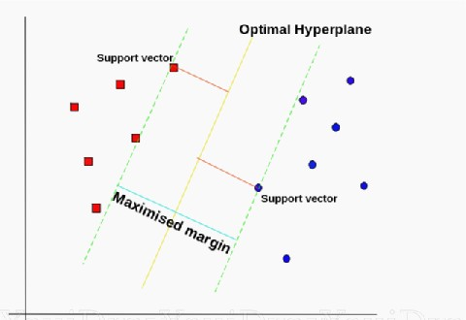 The hyper-plane separates the upper points and lower points and points near the hyper plane are called support vectors which are helpful in calculating the errors from all the points.

**NumPy:**

* NumPy, which stands for Numerical Python, is a library consisting of multidimensional array objects and a collection of routines for processing those arrays. Using NumPy, mathematical and logical operations on arrays can be performed.
* This tutorial explains the basics of NumPy such as its architecture and environment. It also discusses the various array functions, types of indexing, etc.
* An introduction to Matplotlib is also provided. All this is explained with the help of examples for better understanding.

**Matplotlib:**

* Matplotlib is one of the most popular Python packages used for data visualization.
* It is a cross-platform library for making 2D plots from data in arrays. It provides an object-oriented API that helps in embedding plots in applications using Python GUI toolkits such as PyQt, WxPythonotTkinter.
* It can be used in Python and IPython shells, Jupyter notebook and web application servers also.

**Flowchart:**

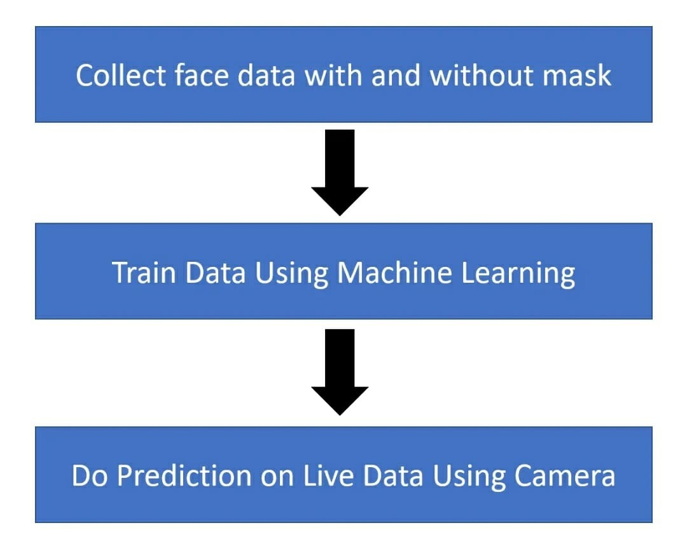

**Working Model:**

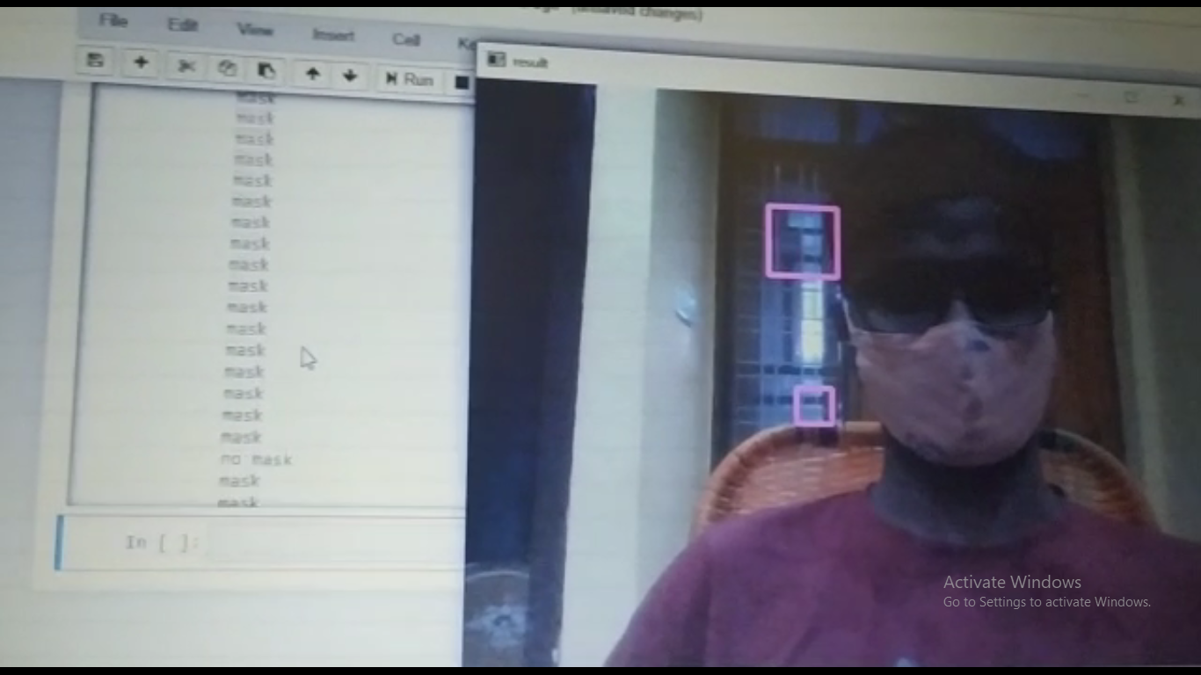

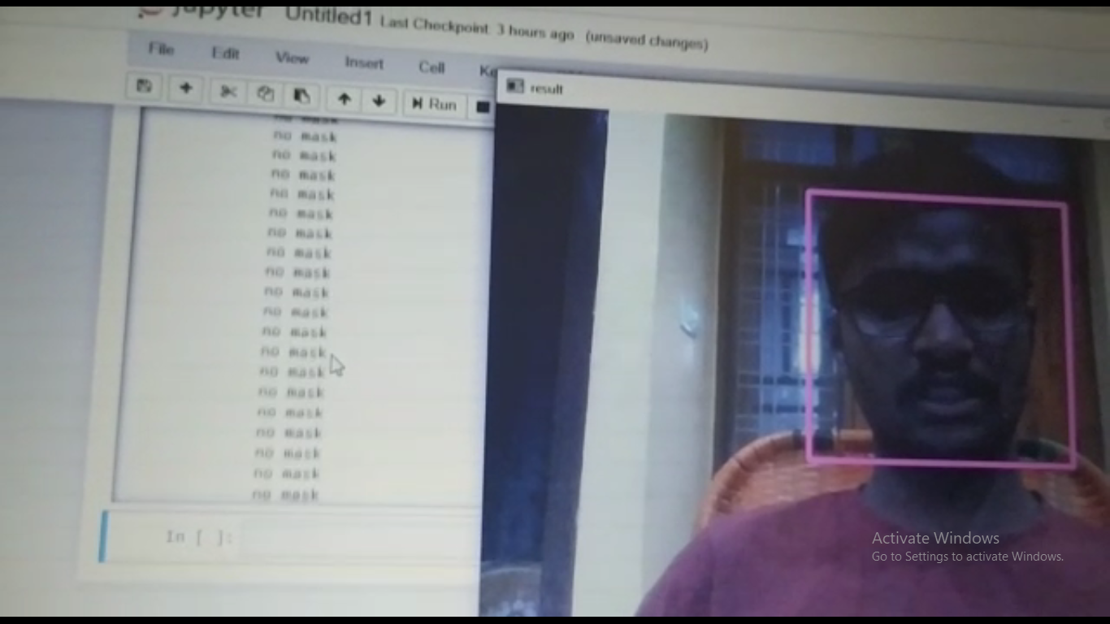

**In this working model we are taking the input through the built-in camera and then we are detecting the faces by using the Haar-Cascade classifier and then we process the image and processing the image to find the mask or not.**

**CODING :**

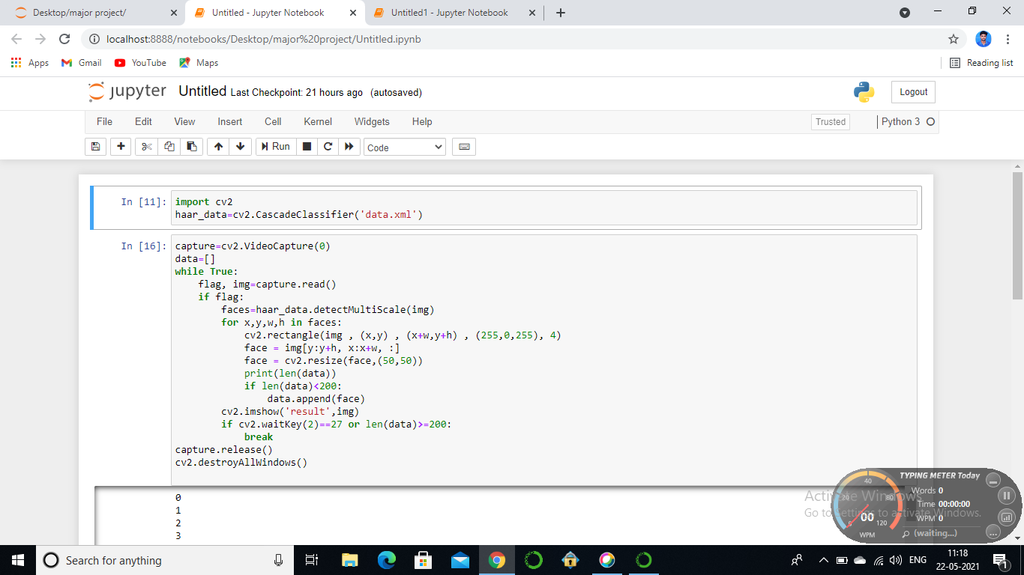

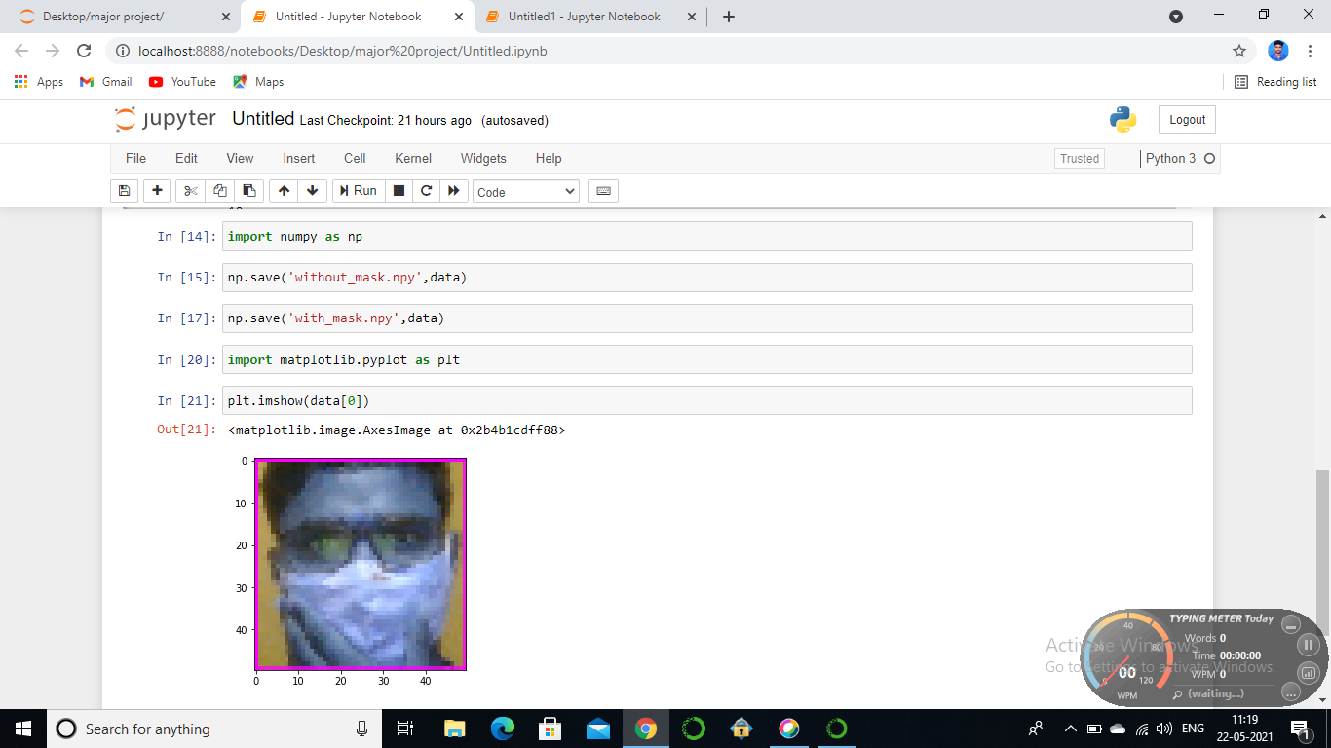

# C:\Users\saikumar\Pictures\Screenshots\Screenshot (67).png

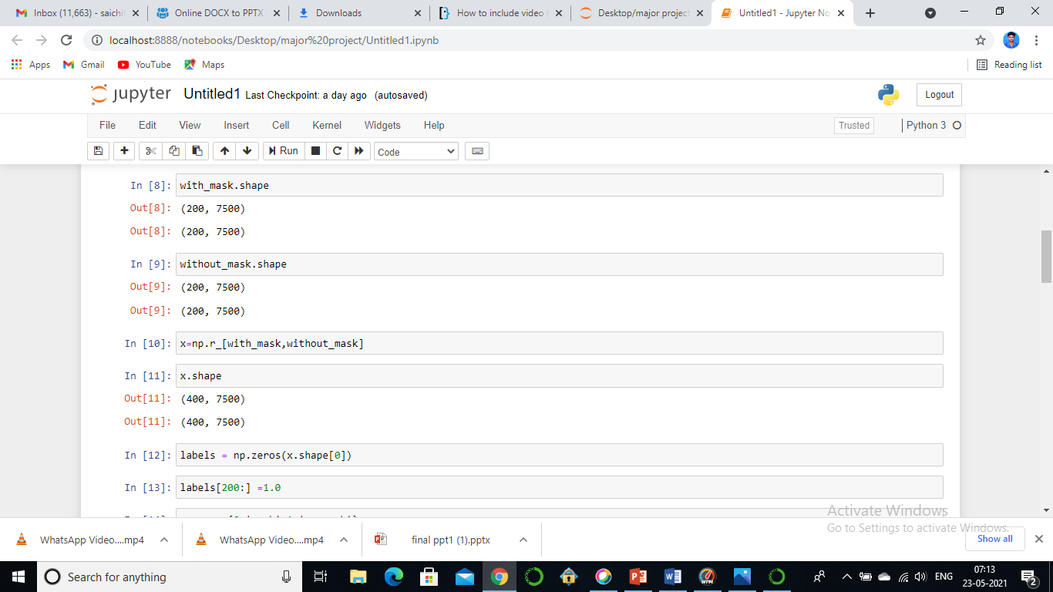

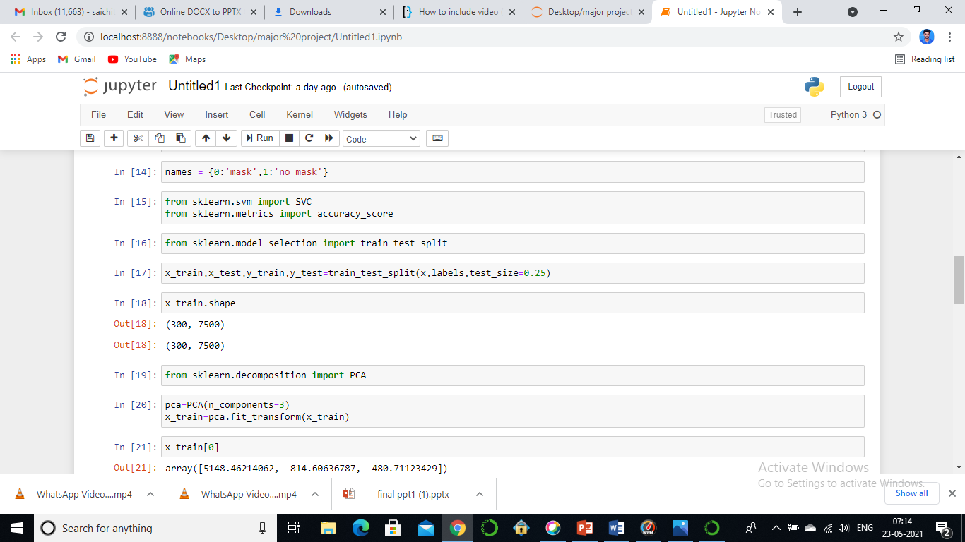

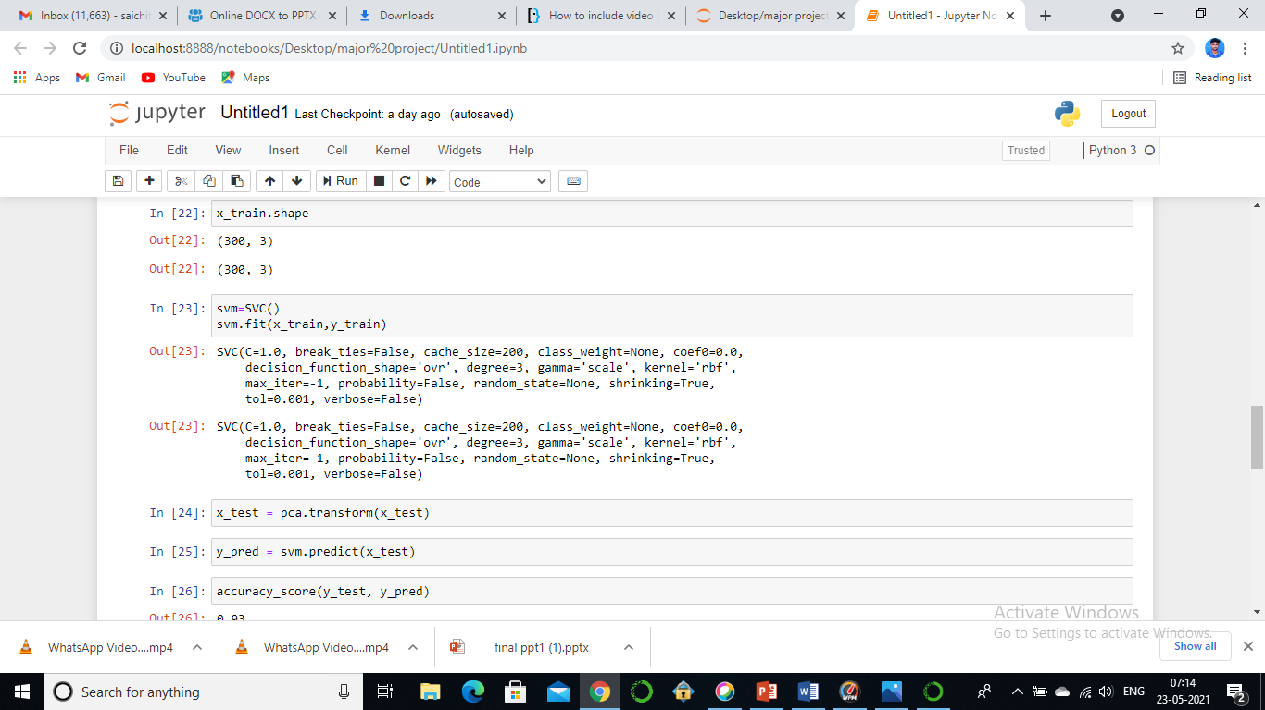

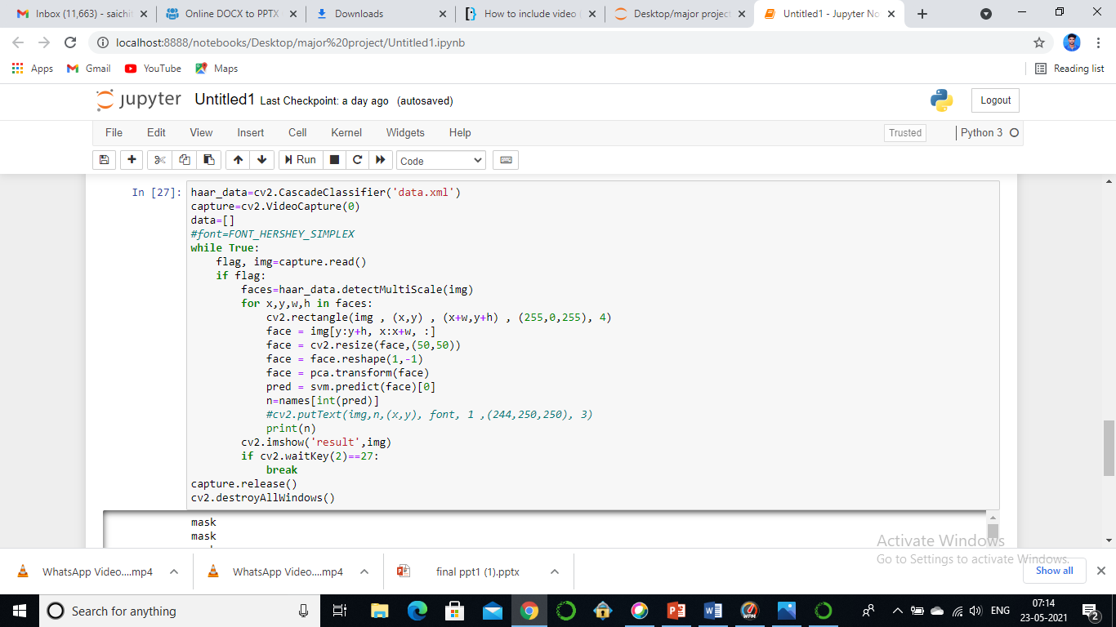

In this model we used open cv for accessing the camera and taken the live streaming.By using the opencv we are going to preprocess the image and we are using the haar cascade classifier to detect the faces we are training the model using the support vector classification model and predicting the face with the mask or not.

# Features

* Automatic- provides truly touchless experience.It’s fast, safe, and simply more efficient.
* Low Cost- It can be implemented with less cost.
* Easy accessibility- can be placed anywhere, convenient way to maintain hygeine control practices.
* Eliminates the contact point.

**Future scope:**

* Automatic hand sanitizing machine to improve hygiene and prevent the infectious viruses entering our body.
* These automatic hand sanitizer machines are developed keeping in mind about its affordability by underprivileged sections of the society as it can be purchased by lower income groups in pursuit of their well being and also they are easily available and can be used by everyone without any hassle.
* More than fifty countries around the world have recently initiated wearing face masks compulsory. People have to cover their faces in public, supermarkets, public transports, offices, and stores. Retail companies often use software to count the number of people entering their stores.
* Software operators can also get an image in case someone is not wearing a mask. Furthermore, an alarm system can also be implemented to sound a beep when someone without a mask enters the area.

## Conclusion

* Automatic hand sanitizer dispensers are better than the traditional ones as they dispense the sanitizer automatically.
* Touchless automatic hand sanitizer dispensers offer an extra layer of protection.
* They can be placed in workspaces,Institutions, offices,crowded areas.
* To mitigate the spread of COVID-19 pandemic, measures must be taken.
* This face mask detector can be deployed in many areas like shopping malls,

airports and other heavy traffic place to monitor the public and to avoid the spread

of the disease by checking who is following basic rules and who is not.

## References

* [https://www.amazon.in/NETBOON-Automatic-Sanitizer-Dispenser-](https://www.amazon.in/NETBOON-Automatic-Sanitizer-Dispenser-Technology/dp/B08CSJBX9Z)

[Technology/dp/B08CSJBX9Z](https://www.amazon.in/NETBOON-Automatic-Sanitizer-Dispenser-Technology/dp/B08CSJBX9Z)

* <https://www.hindustanengineer.in/automatic-hand-sanitizer-dispenser.html>
* [https://www.digikey.com/en/maker/blogs/2020/make-an-automatic-hand-sanitizer-](https://www.digikey.com/en/maker/blogs/2020/make-an-automatic-hand-sanitizer-dispenser-using-arduino)

[dispenser-using-arduino](https://www.digikey.com/en/maker/blogs/2020/make-an-automatic-hand-sanitizer-dispenser-using-arduino)

* <https://shareok.org/bitstream/handle/11244/11052/Wan_okstate_0664D_12910.pdf>

http://www.lboro.ac.uk/well/resources/factsheets/fact-sheets htm/Handwashing.

https://www.theguardian.com/world/2020/feb/2 8/hand-sanitiser-or-hand-washing-which- moreeffective-against- coronavirus-covid

